1.第一页：

请选择第一页图中你认为最好看的几张，不限制数量但尽可能多选，需要从好到一般排序。同时选出你认为最不好看的几张，不限制数量但尽可能多选，需要从最不好看到一般排序。直接将图片复制到word中排序即可。

我认为最好看的一系列图片从最好看到一般好看(从左到右)：

我认为最不好看的一系列图片从最不好看到一般不好看：

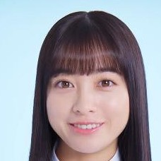

2.第二页：

请选择图中你认为最好看的几张，不限制数量但尽可能多选，需要从好到一般排序。同时选出你认为最不好看的几张，不限制数量但尽可能多选，需要从最不好看到一般排序。

我认为最好看的一系列图片从最好看到一般好看：

我认为最不好看的一系列图片从最不好看到一般不好看：

这页不太符合我的审美

3.第三页：

请选择图中你认为最好看的几张，不限制数量但尽可能多选，需要从好到一般排序。同时选出你认为最不好看的几张，不限制数量但尽可能多选，需要从最不好看到一般排序。

我认为最好看的一系列图片从最好看到一般好看：

我认为最不好看的一系列图片从最不好看到一般不好看：

4.完成上述问题后最后一问：

你认为第二页整体和第三页相比，哪一页更好看？

答：1

你认为这三页的图片总体是从上到下分别按照：

A从好看到不好看排序

B从不好看到好看排序

C乱序

第一页：A

第二页：B

第三页：C